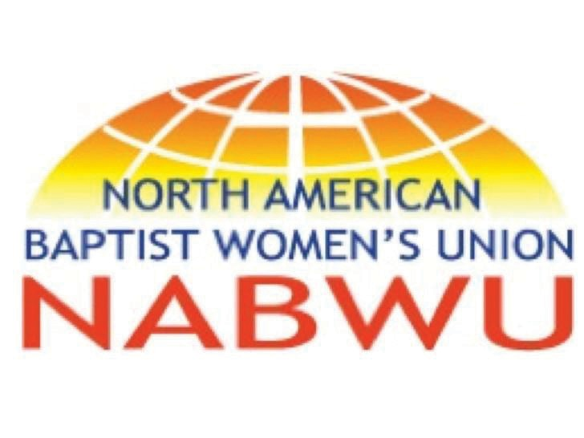

NETWORKING
GROUPS
We, as NABWU, desire to be women who help women who help women. As we network women from our member bodies who work in like ministries, it is with the hope and desire that each of you will be encouraged and built up in the calling that God has given you.

WE BELIEVE:
TOGETHER WE ARE STRONGER.

Contact Information:
Moreen Sharp President president@nabwu.org (403) 632-5022

Ruby Fulbright
Vice President of Networking, Leadership and Mentoring networking@nabwu.org
(919) 395-2351

REPRESENTING 17 MEMBER BODY ORGANIZ ATIONS
IN THE USA AND C ANADA - AFFILIATED WITH THE BAPTIST WORLD ALLIANCE WOMEN’S DEPARTMENT

It is our mission to encourage women
to live out Kingdom life, especially in the area of helping the vulnerable.

TABLE OF C O NTENTS

NETWORKING
GR OUPS
Creative Arts 1
Cross Cultural Mission 7
Disempowered Women 12
Human Trafficking/Prostitution. 24
Leadership Development 37
Poverty 44
Prison Ministries/Ex-Offenders 55
Refugees/New Immigrants 67
Trauma 77
Widows 92
Youth At Risk 94

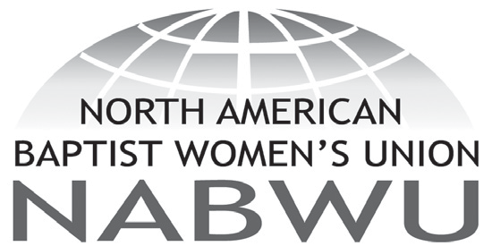
1

NETWORKING
GR OUPS

CRE ATIVE
A RTS

Area of Expertise:
Children/at risk youth, Refugees, Homelessness, Muslim women, Abuse, Joblessness, Sexual addiction, Women in prison, Reaching secular women, Human trafficking, Drug abuse, Environment, Ex- offenders,

Doak, Rev. Joanna
Email: joannadoak@yahoo.com Website: http://chameleonjo.com Contact Address:
579 Squires Street
Fredericton, NB Canada E3B 3V3

Home Phone:
Work Phone: (506) 455-4157

Cell Phone: FAX:

Brief Description of Ministry:
Writes and performs dramas in both secular & Christian venues on any or all of the listed subjects.

NABWU Member Body/Convention:
Atlantic Baptist Women

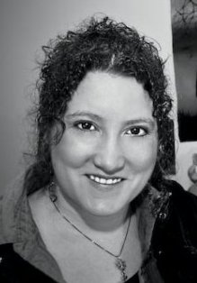

Area of Expertise:
Writing, ministry to pre-teen girls, leading workshops, crafts

Hovsepian, Ann-Margret

Email: ann@annhovsepian.com Website: http://www.annhovsepian.com Contact Address:
5941 Park Ave Montreal, QC H2V 4H4 Home Phone:
Work Phone: (514) 274-3398

Cell Phone: FAX:

Brief Description of Ministry:
Author or co-author of three devotional books for pre-teen girls, free lance journalist and editor, speaker, mentor and amateur artist. Involved in women’s ministry both in local church and regionally. CBWOQ board member.

NABWU Member Body/Convention:
Canadian Baptist Women of Ontario and Quebec

Area of Expertise:
Creative Writing, Journalism

James, Renee

Email: rsejames@gmail.com

Website:
Contact Address:
238 Robina Avenue Toronto, ON M9C 3Z1 Home Phone:
Work Phone: (416) 651-8967

Cell Phone: FAX:

Brief Description of Ministry:
Editor of the live and director of communications for CBWOQ, Freelance journalist

NABWU Member Body/Convention:
Canadian Baptist Women of Ontario and Quebec

Area of Expertise:
Ministry through the arts

McIntosh, Meghan

Email: megmcintosh@alumni.uwaterloo.ca

Website:
Contact Address:
412 Lodor Street Ancaster, ON L9G 2Z8
Home Phone: (905) 648-7778
Work Phone: (905) 648-8657

Cell Phone: FAX:

Brief Description of Ministry:
Meghan speaks to groups and facilitates interactive workshops using her art to visually illustrate her message as she shares the truth of the gospel of Jesus Christ and God’s incredible love to youth, women and men. She likes to integrate a variety of learning styles into multimedia presentation format to meet the needs of participants. Over the years Meghan has taught fiber art workshops and pottery classes, as well as, creates her own work in a variety of media: clay, fiber, watercolor/calligraphy, and multimedia works in her home studio called “Creative Connections”.

NABWU Member Body/Convention:
Canadian Baptist Women of Ontario and Quebec

Area of Expertise:
Creative artist (mixed media), cellist. Facilitates the integration of the arts into worship.

Tiessen, Sharon

Email: tiessenarts@gmail.com
Website: http://www.idrathersellsomeart.com

Contact Address:
230 Campbell Avenue Toronto, ON M6P 3V4 Home Phone:
Work Phone: (416) 538-5947

Cell Phone: FAX:

Brief Description of Ministry:
Creative Artist (mixed media), Cellist. Facilitates the integration of the arts into worship

NABWU Member Body/Convention:
Canadian Baptist Women of Ontario and Quebec

7

NETWORKING
GR OUPS

CROSS
CU LTURAL MISSIO N

Area of Expertise:
Young women’s hygiene/Income generating activity initiative

Alston, Cheryl

Email: SAVE@fountainbaptist.org

Website:
Contact Address: Fountain Baptist Church 116 Glenside Avenue
Summit, NJ 07091

Home Phone:
Work Phone: (908) 273-1199

Cell Phone: FAX:

Brief Description of Ministry:
HELP is a holistic health initiative focusing on feminine hygiene and education. This initiative provides reusable sanitary napkins to young women in eastern and western Kenya, meeting personal needs and also serving as an income generating activity.

NABWU Member Body/Convention:
WA Lott Carey Baptist, Foreign Mission Convention

Area of Expertise:
Majoring in International Studies focus area of International Development and minoring in Spanish Language with a Certificate in Spanish Translation

Chroniger, Bethany

Email: bethany.chroniger@yahoo.com

Website:
Contact Address:
P.O. Box 145
Shiloh, NJ 08353 -0145
Home Phone: (856) 455-0488

Work Phone:
Cell Phone: (609) 364-2904

FAX:

Brief Description of Ministry:
Really feel called to international missions. Past Mission trips: - Pittsburgh Project - Construction work and house repair for those who could not afford to do it themselves. - The Rez Connection
- worked with the Native American children, as well as helped out the missionaries there with farm work. - Malawi, Africa - renovated a house, visited medical clinics and rural churches. - Joinville/ Curitiba, Brazil - worked with local churches/branch churches, did child based outreach (VBS type things) led worship. - Muna/Merida, Mexico (3 times) led worship, preached, did child based outreach.
- Iquitos, Peru - more child based outreach and teaching. Going to serve as a small group Bible Study Leader on college campus for this coming year.

NABWU Member Body/Convention:
Seventh Day Baptist General Conference Women’s Society

Area of Expertise:
Bible translation ministries, strategic associate with Wycliffe Bible Translators

Friesen, Dianne

Email: Dianne_Friesen@sil.org

Website:
Contact Address:
4 Riverview Drive
Sydney River, NS, Canada B1S 1N5
Home Phone: (902) 567-2737
Work Phone: (902) 578-9623

Cell Phone: FAX:

Brief Description of Ministry:
Language work and Bible translation. Collaborate with Mi’kmaq people in church and educational fields to study and develop Mi’kmaq language, translate some of the Bible into Mi’kmaq, and to empower Mi’kmaq people to do the same.

NABWU Member Body/Convention:
Atlantic Baptist Women

Area of Expertise:
Women and men dealing with depression, trauma and pain

Holwyn, Faith

Email: faith.holwyn@gmail.com Website: http://www.groupsofhope.ca Contact Address:
280 Hollywood Ave Toronto, ON M2N 3K9 Home Phone:
Work Phone: (416) 850-7529

Cell Phone: FAX:

Brief Description of Ministry:
Founder of Groups of Hope. This eight-week program, developed while Faith was working as a psychiatric nurse in Canada’s indigenous communities, encourages participants, in groups of 10 to 12, to begin to trust each other and to rediscover the reality of God walking with us through difficult times. A 2010 Day of Prayer offering Project.

NABWU Member Body/Convention:
Canadian Baptist Women of Ontario and Quebec

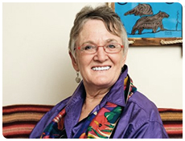

12

NETWORKING
GR OUPS

DISEMPOWERED
WOMEN

Area of Expertise:
Young women’s hygiene/Income generating activity initiative

Alston, Cheryl

Email: SAVE@fountainbaptist.org

Website:
Contact Address: Fountain Baptist Church 116 Glenside Avenue
Summit, NJ 07091

Home Phone:
Work Phone: (908) 273-1199

Cell Phone: FAX:

Brief Description of Ministry:
HELP is a holistic health initiative focusing on feminine hygiene and education. This initiative provides reusable sanitary napkins to young women in eastern and western Kenya, meeting personal needs and also serving as an income generating activity.

NABWU Member Body/Convention:
WA Lott Carey Baptist, Foreign Mission Convention

Area of Expertise:
Ministry to Homeless
Bennett, Kay – Executive Director, Baptist Friendship House Email: kbennettbfh@aol.com
Website: http://www.baptistfriendshiphouse.org/

Contact Address:
813 Elysian Fields Ave. New Orleans, LA 70117 Home Phone:
Work Phone: (504) 949-4469

Cell Phone: FAX:

Brief Description of Ministry:
Ministry to Homeless. Transitional Housing for homeless women with children, summer teen girls program, community ministries, literacy training, job readiness skills, referrals, English as a second language, school supplies and resources.

NABWU Member Body/Convention:
Woman’s Missionary Union

Area of Expertise:
Sister Connection

Crawford, Rev. Betty M

Email: revbettyc@aol.com

Website:
Contact Address:
1008 Fenton Place
Upper Marlboro, MD 20774

Home Phone:
Work Phone: (301) 333-4367

Cell Phone: FAX:

Brief Description of Ministry:
Sister Connection is an outreach project whose mission is to establish a Christian connection with women living in Group Home Facilities located in our communities with the spiritual nurture and temporal assistance. Sister Connection seeks to establish and/or re-establish a four-fold connection, namely, 1) Connect facility Sisters (residents) to Christ, 2) Connect facility Sisters to His Word and His Church,
3) Reconnect facility Sisters to their Families, 4) Re-connect facility Sisters to the Community

NABWU Member Body/Convention:
Progressive National Baptist Convention Women’s Department

Area of Expertise:
Outreach to Women in Transition, Women In Prison, Reaching Secular Women

Davis, Paula S.

Email: paula.davis@gmail.com

Website:
Contact Address:
162 S. Vista
Auburn Hills, MI 48326
Home Phone: (248) 253-9252
Work Phone: (248) 753-1295

Cell Phone:
FAX: (248) 753-0324

Brief Description of Ministry:
Since November 18, 1995, the Fashion Share Outreach Project has been held at the Trinity Missionary Baptist Church of Pontiac, Michigan. The Fashion Share Outreach is a mission project where women and their children from selected shelters in the area are invited to “share” and are treated as “Queens for the Day”. A beautiful lunch is prepared, encouraging words are spoken, and the guests are given the opportunity to “shop” for clothing is displayed as in a clothing department store. Child care is provided for their children and includes fun activities and a lunch more to their liking (pizza, hot dogs and hamburgers), clothing and school supplies are also made available. The main message of this outreach is to give dignity and respect to women who are attempting to make a transition to get back on their feet, attend school or return to the workforce in their efforts to make a respectable living for them and their children. The mandate for the project comes from the Holy Word found in Matthew 25:35-40.

NABWU Member Body/Convention:
Woman’s Auxiliary to the National Baptist Convention, USA, Inc.

Area of Expertise:
Christian Women’s Job Corps/Christian Men’s Job Corps

Gholson, Tracey

Email: gholsont@bellsouth.net

Website:
Contact Address:
7605 Staffordshire Drive
Nashville, TN 37221

Home Phone:
Work Phone: (615) 646-1078

Cell Phone: FAX:

Brief Description of Ministry:
CWJC and CMJC seek to provide a Christian environment in which women and men in need are equipped and encouraged for new life in Jesus and where they gain job skills for employment in order to enhance their lives and the lives of their families.

NABWU Member Body/Convention:
Woman’s Missionary Union

Area of Expertise:
Coordinator/Teacher/Advisor for Women Mentoring Women (WMW) Project

Hamlin, Rev. Dollie S.

Email: shelita1956@yahoo.com; Dollieh@pmua.org

Website:
Contact Address:
c/o Ruth Fellowship Ministries 733 South 2nd Street
PO Box 3076
Plainfield, NJ 07060-2003

Home Phone: Work Phone:
Cell Phone: (908) 922-2485

FAX:

Brief Description of Ministry:
Training designed for disadvantaged women to learn new skills and/ or improve on specific skills already learned. 2012 NABWU Day of Prayer Project

NABWU Member Body/Convention:
Woman’s Auxiliary to the National Baptist Convention, USA, Inc.

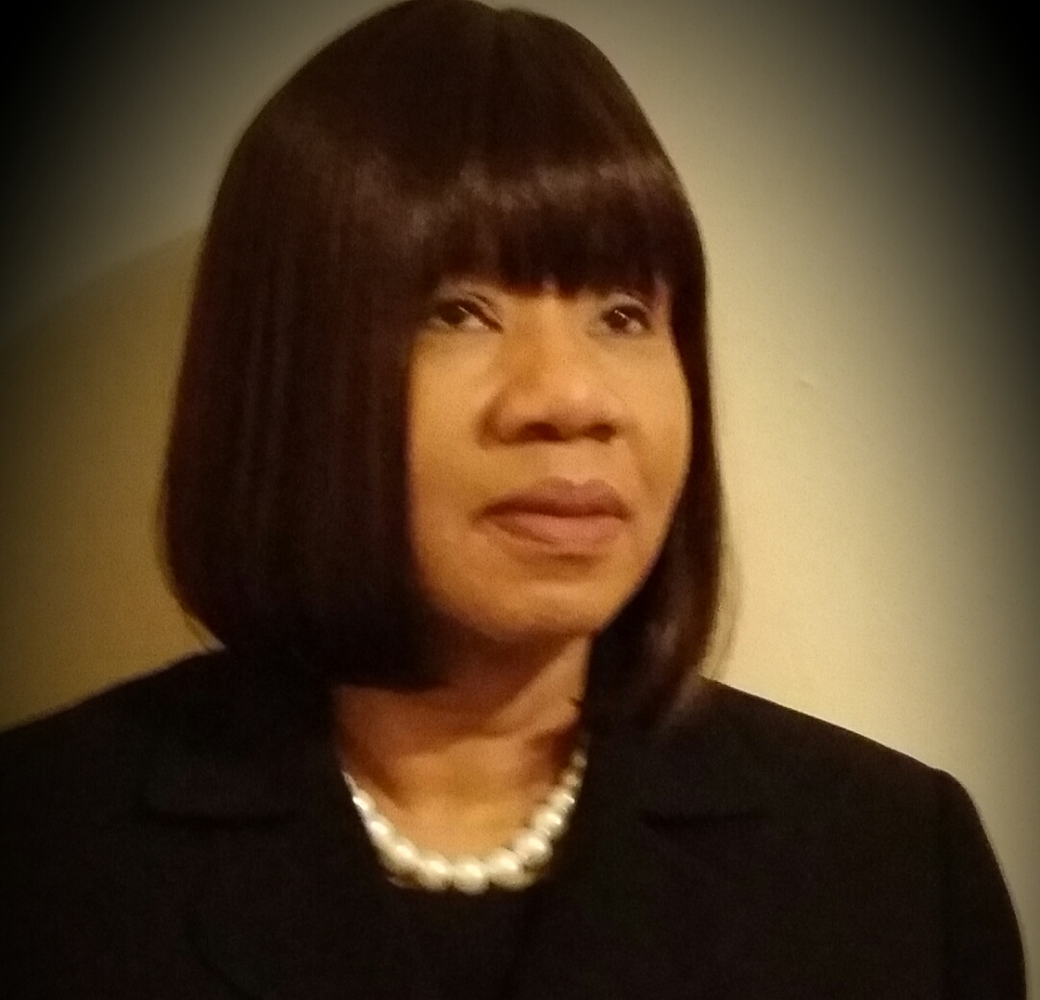

Area of Expertise:
Women’s Ministry Leader

Mallory, Charlotte

Email: SAVE@fountainbaptist.org

Website:
Contact Address: Fountain Baptist Church 116 Glenside Avenue
Summit, NJ 07901

Home Phone:
Work Phone: (908) 273-1199

Cell Phone: FAX:

Brief Description of Ministry:
SAVE is an empowerment group, of churches, partnering to help women overcome the effects of violence and abuse. Transforming pain into power enhances the quality of life across every age group.

NABWU Member Body/Convention:
WA Lott Carey Baptist, Foreign Mission Convention

Area of Expertise:
Disadvantaged women. Founder and co-leader (with Sharena Turner and Rev. Della Bost) of God’s Lending Hands
McNeely-Boyce,Cynthia
Email: cynbag@sympatico.ca

Website:
Contact Address: 1182 Parkview Ave Windsor, ON N8S 2X9
Home Phone: (519) 251-1635
Work Phone: (519) 257-6231

Cell Phone: FAX:

Brief Description of Ministry:
Provides workshops, discussions, peer mentoring, potluck meals, and biblical guidance to low-income single mothers, plus activities for their children. (2011 NABWU Day of Prayer Project)

NABWU Member Body/Convention:
Canadian Baptist Women of Ontario and Quebec

Area of Expertise:
Transitional support for incarcerated and homeless women
Miller, Cheryl – Executive Director Email:
Website: http://perpetualhelphome.org

Contact Address:
P.O. Box 4305 Victoria, TX 77903 Home Phone:
Work Phone: (361) 575-5335

Cell Phone

FAX:

Brief Description of Ministry:
Perpetual Help Home, Inc. is a Christian based restorative justice organization assisting women in breaking the cycle of incarceration and homelessness through making life changes, regardless of race, color, or creed. We help women become productive members of society with transitional support, new life-skills training and permanent supportive housing.

NABWU Member Body/Convention:
Woman’s Missionary Union

Area of Expertise:
Coordinator of Training for Women Mentoring Women (WMW)

Suggs, Nellie

Email: nellie.suggs@verizon.net

Website:
Contact Address:
214 Livingston St
Westfield, NJ 07090

Home Phone:
Work Phone: (908) 698-2020

Cell Phone: FAX:

Brief Description of Ministry:
Training designed for disadvantaged women to learn new skills and/ or improve on specific skills already learned. 2012 NABWU Day of Prayer Project

NABWU Member Body/Convention:
Woman’s Auxiliary to the National Baptist Convention, USA, Inc.

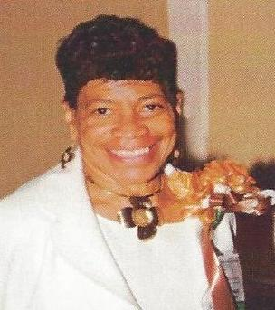

Area of Expertise:

Pregnancy Care

Connie Thurber

Executive Director
Pregnancy Resource Centre of Moncton

Contact Address: 27 John Street, Moncton, NB, E1C 8G9
Website: www.pregnancysupport.ca
Work Phone: 506-857-3039
Cell Phone: 506-229-1562

The Pregnancy Resource Centre values human life by caring for, supporting, and equipping women facing unplanned pregnancy. For the past 28 years we have served our community – providing prenatal & parenting classes, options counseling, material support and a variety of other group sessions. Fall of 2015 our goal is to provide limited healthcare services by hiring a registered nurse, and provide STI testing and medical confirmation of pregnancy.
We are a not for profit, faith based, organization- totally funded by the community.

NABWU Member Body/Convention:
Atlantic Baptist Women

Area of Expertise:
Intentional Innovative Community Evangelism (IICE)

Yandell, Marjorie

Email: vmy@att.net

Website:
500 Baker Road
Fredonia, KY 42411
Home Phone: (270) 545-3429
Work Phone: (270) 545-3429

Cell Phone: FAX:

Brief Description of Ministry:
IICE is a friendly, non-threatening evangelistic outreach that offers free carnival games for block parties hosted by churches. They hope to expand these “Freedom Festivals” to a women’s prison, homeless women, seniors’ homes, and low- income families in public housing. 2012 NABWU Day of Prayer Project

NABWU Member Body/Convention:
Woman’s Missionary Union
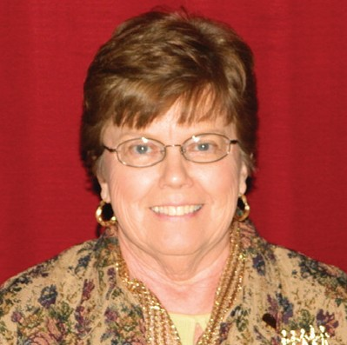

24

NETWORKING
GR OUPS

HUMAN TRAFFICKING/ PROSTITUTIO N

Area of Expertise:
Pastoral Care Counseling, specializing in traumatic injury

Clifton, Rev. Dr. Angelita

Email: POAC@aol.com; SAVE@fountainbaptist.org

Website:
Contact Address: Fountain Baptist Church 116 Glenside Avenue
Summit, NJ 07091

Home Phone:
Work Phone: (908) 273-1199

Cell Phone: FAX:

Brief Description of Ministry:
1.) Anti-Trafficking Initiative mobilizing to work and pray for women victimized by gender based violence. 2.) SAVE is an empowerment group helping women overcome violence, abuse and traumatic events. 3.) CAN is a commission of compassionate caregivers from multiple ministerial initiatives partnering to do God’s work domestically and abroad.

NABWU Member Body/Convention:
WA Lott Carey Baptist, Foreign Mission Convention

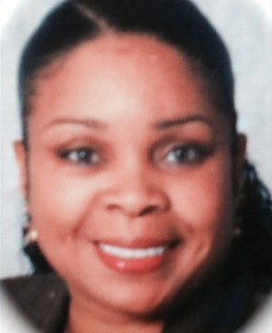

Area of Expertise:
Christian Faith Baptist Church ATI Facilitator for North Carolina and beyond

Cooper, Lakeeyna

Email: kikicooper@verizon.net

Website:
Contact Address:
509 Hilltop Drive
PO Box 28181
Raleigh, NC 27611

Home Phone:
Work Phone: (918) 833-5834
Cell Phone: (973) 738-2107

FAX:
Brief Description of Ministry:
Anti-Human Trafficking Initiative that mobilizes to pray and work for women who are victims of gender based violence.

NABWU Member Body/Convention:
WA Lott Carey Baptist, Foreign Mission Convention

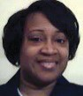

Area of Expertise:
Lott Carey Program Coordinator - Women

Crump, Barbara

Email: btcrump@yahoo.com

Website:
Contact Address:
220 I Street, NE. Suite 220
Washington, DC 20002-4389

Home Phone:
Work Phone: (202) 543-3200

Cell Phone: FAX:

Brief Description of Ministry:
Anti-Human Trafficking Initiative that mobilizes women to pray and work for women who are victims of gender based violence.

NABWU Member Body/Convention:
WA Lott Carey Baptist, Foreign Mission Convention

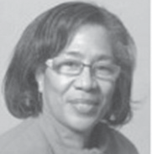

Area of Expertise:
Women in the sex trade, children at risk, physical and sexual abuse, sexual addiction, drug abuse, homelessness, reaching secular women

Forster, Donna

Email : donna.forster7@gmail.com

Website:
Contact Address: 4252 Ponderosa Cr, Victoria, BC V8Z 7G2 Home Phone:
Work Phone: (250) 727-0921

Cell Phone: FAX:

Brief Description of Ministry:
Street ministry to prostitutes, drug addicts, women in escort agencies and to children in public schools.

NABWU Member Body/Convention:
Women in Focus
(Canadian Baptist Women of Western Canada)

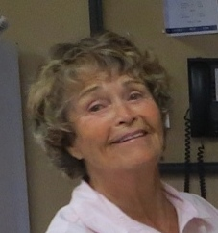

Area of Expertise:
Educator around the issues of human trafficking

Grover, Tomi, Dr.

Email: tomi@tomigrover.com
Website: www.traffickstop.org and http://www.tomigrover.com

Contact Address:
c/o Baptist General Convention of Texas 333 N. Washington Ave.
Dallas, TX 75246-1798

Work Phone: (214) 418-8318

Brief Description of Ministry:
Tomi Grover serves as an educator in human trafficking. She wrote "Compelled" to educate the Christian church about why and how they can respond to trafficking. She is currently involved in several initiatives. Tomi holds a Doctor of Philosophy in Social Work and Ministry-Based Evangelism. She is the founder of TraffickStop.

NABWU Member Body/Convention:
American Baptist/Baptist General Convention of Texas

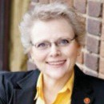

Area of Expertise:
Awareness, Rescue, Restoration and Re-entry around the issues of human trafficking

Johnson, Sandra

Email: sandra@triadladderofhope.org

Website: www.triadladderofhope.org
Contact Address:
c/o Triad Ladder of Hope Box 470
High Point, NC 27262

Home Phone:
Work Phone: (336) 906-3844

Cell Phone: FAX:

Brief Description of Ministry:
President and Founder of Triad Ladder of Hope in North Carolina, Christian Women’s Job Corps Project

Website: www.triadladderofhope.org

NABWU Member Body/Convention:
Woman’s Missionary Union

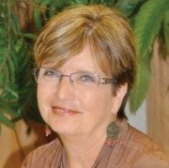

Area of Expertise:
Mission Service Corps Missionary, NAMB, Human Trafficking and Sexual Exploitation of Children

McCormick, Sharon Fields

Email: sfieldsmccormick@bellsouth.net
Website: http://jackandsharon.blogspot.com http://www.sharonfieldsmccormick.com

Contact Address:
1424 Firetower Rd
Williamston, SC 29697

Home Phone:
Work Phone: (678) 313-3966

Cell Phone: FAX:
Brief Description of Ministry:
Advocate for victims of human trafficking. Sharon presents the “Right Where You Live” workshop in churches across the U.S. to increase awareness of commercial sexual exploitation of children, teaching churches how to minister to not only the victims but the offenders who are in their congregations

NABWU Member Body/Convention:
Woman’s Missionary Union

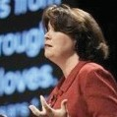

Area of Expertise:
Human Trafficking and Prostitution

Email:
Website: http://www.embracedignity.org Contact Address:
REED
1424 Commercial Drive
PO Box 21732
Vancouver, BC V5L 5G3

Work Phone: (604) 725-3838

Brief Description of Ministry:
Executive Director of REED (Resist Exploitation, Embrace Dignity). REED seeks to end trafficking and sexual exploitation through outreach, advocacy and education. They work at both the systemic and individual levels including serving women, providing consultation to the RCMP and service providers, including churches and community groups, and advocating for the abolition of the sex industry (which creates the demand for prostituted women).

Website: www.embracedignity.org

NABWU Member Body/Convention:
Women In Focus
(Canadian Baptists of Western Canada)

Area of Expertise:
Women at Risk

Omanson, Susan

Email:
Website: www.befree58.org

Contact Address:
225 E. 11th St., Suite 103 Sioux Falls, SD 557104 Home Phone:
Work Phone: (605) 261-6183

Cell Phone: FAX:

Brief Description of Ministry:
Be Free - Isaiah 58 Ministries Director. Combatting the scourge of human slavery and trafficking. BE FREE is now focusing on the challenges we face in my home state of South Dakota and the Upper Midwest. What a shock to realize the level of exploitation we have during the hunting season and Sturgis Motorcycle Rally! Teens are being approached by pimps at the malls and trafficked at truck stops across the Upper Midwest. Sexual brokenness is taking a terrible toll on the lives of our citizens as they become addicted to pornography, internet sex and other at-risk sexual behaviors. Join us as we seek to bring awareness of these issues and work with other organizations and individuals to bring an end to sex slavery and exploitation on a global and local level. ABOLITION!

NABWU Member Body/Convention: American Baptist Women’s Ministries American Baptist Churches USA

Area of Expertise:
Ministry to Refugees and victims of human trafficking

Phillips, Cathie

Email: dcphillips2006@yahoo.ca

Website:
Contact Address:
4651C Kingston Road Scarborough, ON M1E 2P8 Home Phone:
Work Phone: (416) 735-4661

Cell Phone: FAX:

Brief Description of Ministry:
Extensive and intensive international experience at the hub of the refugee and human trafficking highways

NABWU Member Body/Convention:
Canadian Baptist Women of Ontario and Quebec

37

NETWORKING
GR OUPS

LEADERSHIP DEVE LOPMENT

Area of Expertise:
Sister Connection

Crawford, Rev. Betty M

Email: revbettyc@aol.com

Website:
Contact Address:
1008 Fenton Place
Upper Marlboro, MD 20774

Home Phone:
Work Phone: (301) 333-4367

Cell Phone: FAX:

Brief Description of Ministry:
Sister Connection is an outreach project whose mission is to establish a Christian connection with women living in Group Home Facilities located in our communities with the spiritual nurture and temporal assistance. Sister Connection seeks to establish and/or re-establish a four-fold connection, namely, 1) Connect facility Sisters (residents) to Christ, 2) Connect facility Sisters to His Word and His Church,
3) Reconnect facility Sisters to their Families, 4) Re-connect facility Sisters to the Community

NABWU Member Body/Convention:
Progressive National Baptist Convention Women’s Department

Area of Expertise:
Leadership development, camping ministries, writing, drama, teaching/speaking, Biblical counselor

Ellsworth, Linda

Email: lin.ells@sympatico.ca

Website:
Contact Address:
58 Loxton Line Powassan, ON POH 1Z3 Home Phone:
Work Phone: (705) 724-2456

Cell Phone: FAX:

Brief Description of Ministry:
As a Christian Education graduate of Briercrest Bible College (Sask), God has granted 44 years of leadership service in the Christian Camping ministry in three provinces, as well as 30 years in education. Presently Executive Director of Camp Norland Christian Ministries, Inc., located half-way between North Bay and Sudbury. Husband Doug, is a High School teacher and they are blessed with three children and 5 grandchildren...so far!

NABWU Member Body/Convention:
Canadian Baptist Women of Ontario and Quebec

Area of Expertise:
Pastoring, leadership, preaching, empowering women/women in ministry, marriage

Friesen, Leanne

Email: leanne@mhbc.ca Website: www.mhbc.ca Contact Address:
40 Alpine Ave Hamilton, ON L9A 1A5
Home Phone: (905) 387-9202
Work Phone: (905) 575-0570

Cell Phone: FAX:

Brief Description of Ministry:
Senior Pastor of a diverse city church

NABWU Member Body/Convention:
Canadian Baptist Women of Ontario and Quebec

Area of Expertise:
Secular women, Children, Christian Education & Mentorship

Janzen, Dr. Carol Anne

Email: carol.anne.janzen@acadiau.ca

Website:
Contact Address:
1067 Upper Church St. Kentville, NS, Canada B4N 3V7 Home Phone:
Work Phone: (902) 678-3641

Cell Phone: FAX:

Brief Description of Ministry:
Assistant Professor of Practical Theology, Assistant to the Director of Mentored Ministry Program, Dean of Students at Acadia Divinity College. Current interests are children’s spiritual formation, peace and justice education, faith and culture, sacred place and space, and church history.

NABWU Member Body/Convention:
Atlantic Baptist Women

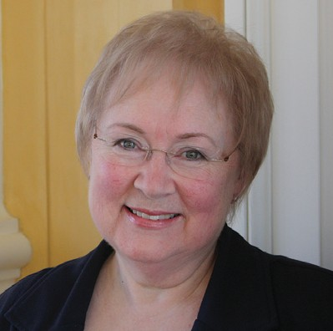

Area of Expertise:
Leadership development, writing, teaching/speaking, Biblical counselor

Johnson, Celeste, Dr.

Email: celesteaj@aol.com

Website:
Contact Address:
339 Oakland Street, # 8
Manchester, CT 06040

Home Phone:
Work Phone: (860) 432-4479

Cell Phone: FAX:

Brief Description of Ministry:
The Ministry of Empowerment: Surviving Our Age of 21 Century Secular World Events

NABWU Member Body/Convention:
Past President of the International Association of Ministers’ Wives and Ministers’ Widows

Area of Expertise:
Bible Study Youth Teacher, Secretarial and Fund Raising Ministries

Umana, Karen

Email: umana79@yahoo.com

Website:
Contact Address:
5005 Larry Court
Woodbridge, VA 22193

Home Phone:
Work Phone: (703) 798-2843

Cell Phone: FAX:

Brief Description of Ministry:
Coordinator of 3 ministries - in charge of Bible Study for the younger youth class, Secretarial Ministry, Secretary and Vice President of Fund Raising.

NABWU Member Body/Convention:
Seventh Day Baptist General Conference Women’s Society

44

NETWORKING
GR OUPS

PO VE RTY

Area of Expertise:
Young women’s hygiene/Income generating activity initiative

Alston, Cheryl

Email: SAVE@fountainbaptist.org

Website:
Contact Address: Fountain Baptist Church 116 Glenside Avenue
Summit, NJ 07091

Home Phone:
Work Phone: (908) 273-1199

Cell Phone: FAX:

Brief Description of Ministry:
HELP is a holistic health initiative focusing on feminine hygiene and education. This initiative provides reusable sanitary napkins to young women in eastern and western Kenya, meeting personal needs and also serving as an income generating activity.

NABWU Member Body/Convention:
WA Lott Carey Baptist, Foreign Mission Convention

Area of Expertise:
Ministry to Homeless
Bennett, Kay – Executive Director, Baptist Friendship House Email: kbennettbfh@aol.com
Website: http://www.baptistfriendshiphouse.org/

Contact Address:
813 Elysian Fields Ave. New Orleans, LA 70117 Home Phone:
Work Phone: (504) 949-4469

Cell Phone: FAX:

Brief Description of Ministry:
Ministry to Homeless. Transitional Housing for homeless women with children, summer teen girls program, community ministries, literacy training, job readiness skills, referrals, English as a second language, school supplies and resources.

NABWU Member Body/Convention:
Woman’s Missionary Union

Area of Expertise:
Outreach to Women in Transition, Women In Prison, Reaching Secular Women

Davis, Paula S.

Email: paula.davis@gmail.com;

Website:
Contact Address:
162 S. Vista
Auburn Hills, MI 48326
Home Phone: (248) 253-9252
Work Phone: (248)753-1295
FAX: (248) 753-0324

Brief Description of Ministry:
Since November 18, 1995, the Fashion Share Outreach Project has been held at the Trinity Missionary Baptist Church of Pontiac, Michigan. The Fashion Share Outreach is a mission project where women and their children from selected shelters in the area are invited to “share” and are treated as “Queens for the Day”. A beautiful lunch is prepared, encouraging words are spoken, and the guests are given the opportunity to “shop” for clothing is displayed as in a clothing department store. Child care is provided for their children and includes fun activities and a lunch more to their liking (pizza, hot dogs and hamburgers), clothing and school supplies are also made available. The main message of this outreach is to give dignity and respect to women who are attempting to make a transition to get back on their feet, attend school or return to the workforce in their efforts to make a respectable living for them and their children. The mandate for the project comes
from the Holy Word found in Matthew 25:35-40.

NABWU Member Body/Convention:
Woman’s Auxiliary to the National Baptist Convention, USA, Inc.

Area of Expertise:
Children/at risk youth, Refugees, Homelessness, Muslim women, Abuse, Joblessness, Sexual addiction, Women in prison, Reaching secular women, Human trafficking, Drug abuse, Environment, Ex- offenders

Doak, Rev. Joanna

Email: joannadoak@yahoo.com Website: http://chameleonjo.com Contact Address:
579 Squires Street
Fredericton, NB Canada E3B 3V3

Home Phone:
Work Phone: (506) 455-4157

Cell Phone: FAX:

Brief Description of Ministry:
Writes and performs dramas in both secular & Christian venues on any or all of the listed subjects.

NABWU Member Body/Convention:
Atlantic Baptist Women

Area of Expertise:
Women in the sex trade, children at risk, physical and sexual abuse, sexual addiction, drug abuse, homelessness, reaching secular women

Forster, Donna

Email:donna.forster7@gmail.com

Contact Address: 4252 Ponderosa Cr, Victoria, BC V8Z 7G2

Work Phone: (250) 727-0921

Brief Description of Ministry:
Street ministry to prostitutes, drug addicts, women in escort agencies and to children in public schools.

NABWU Member Body/Convention:
Women in Focus
(Canadian Baptist Women of Western Canada)

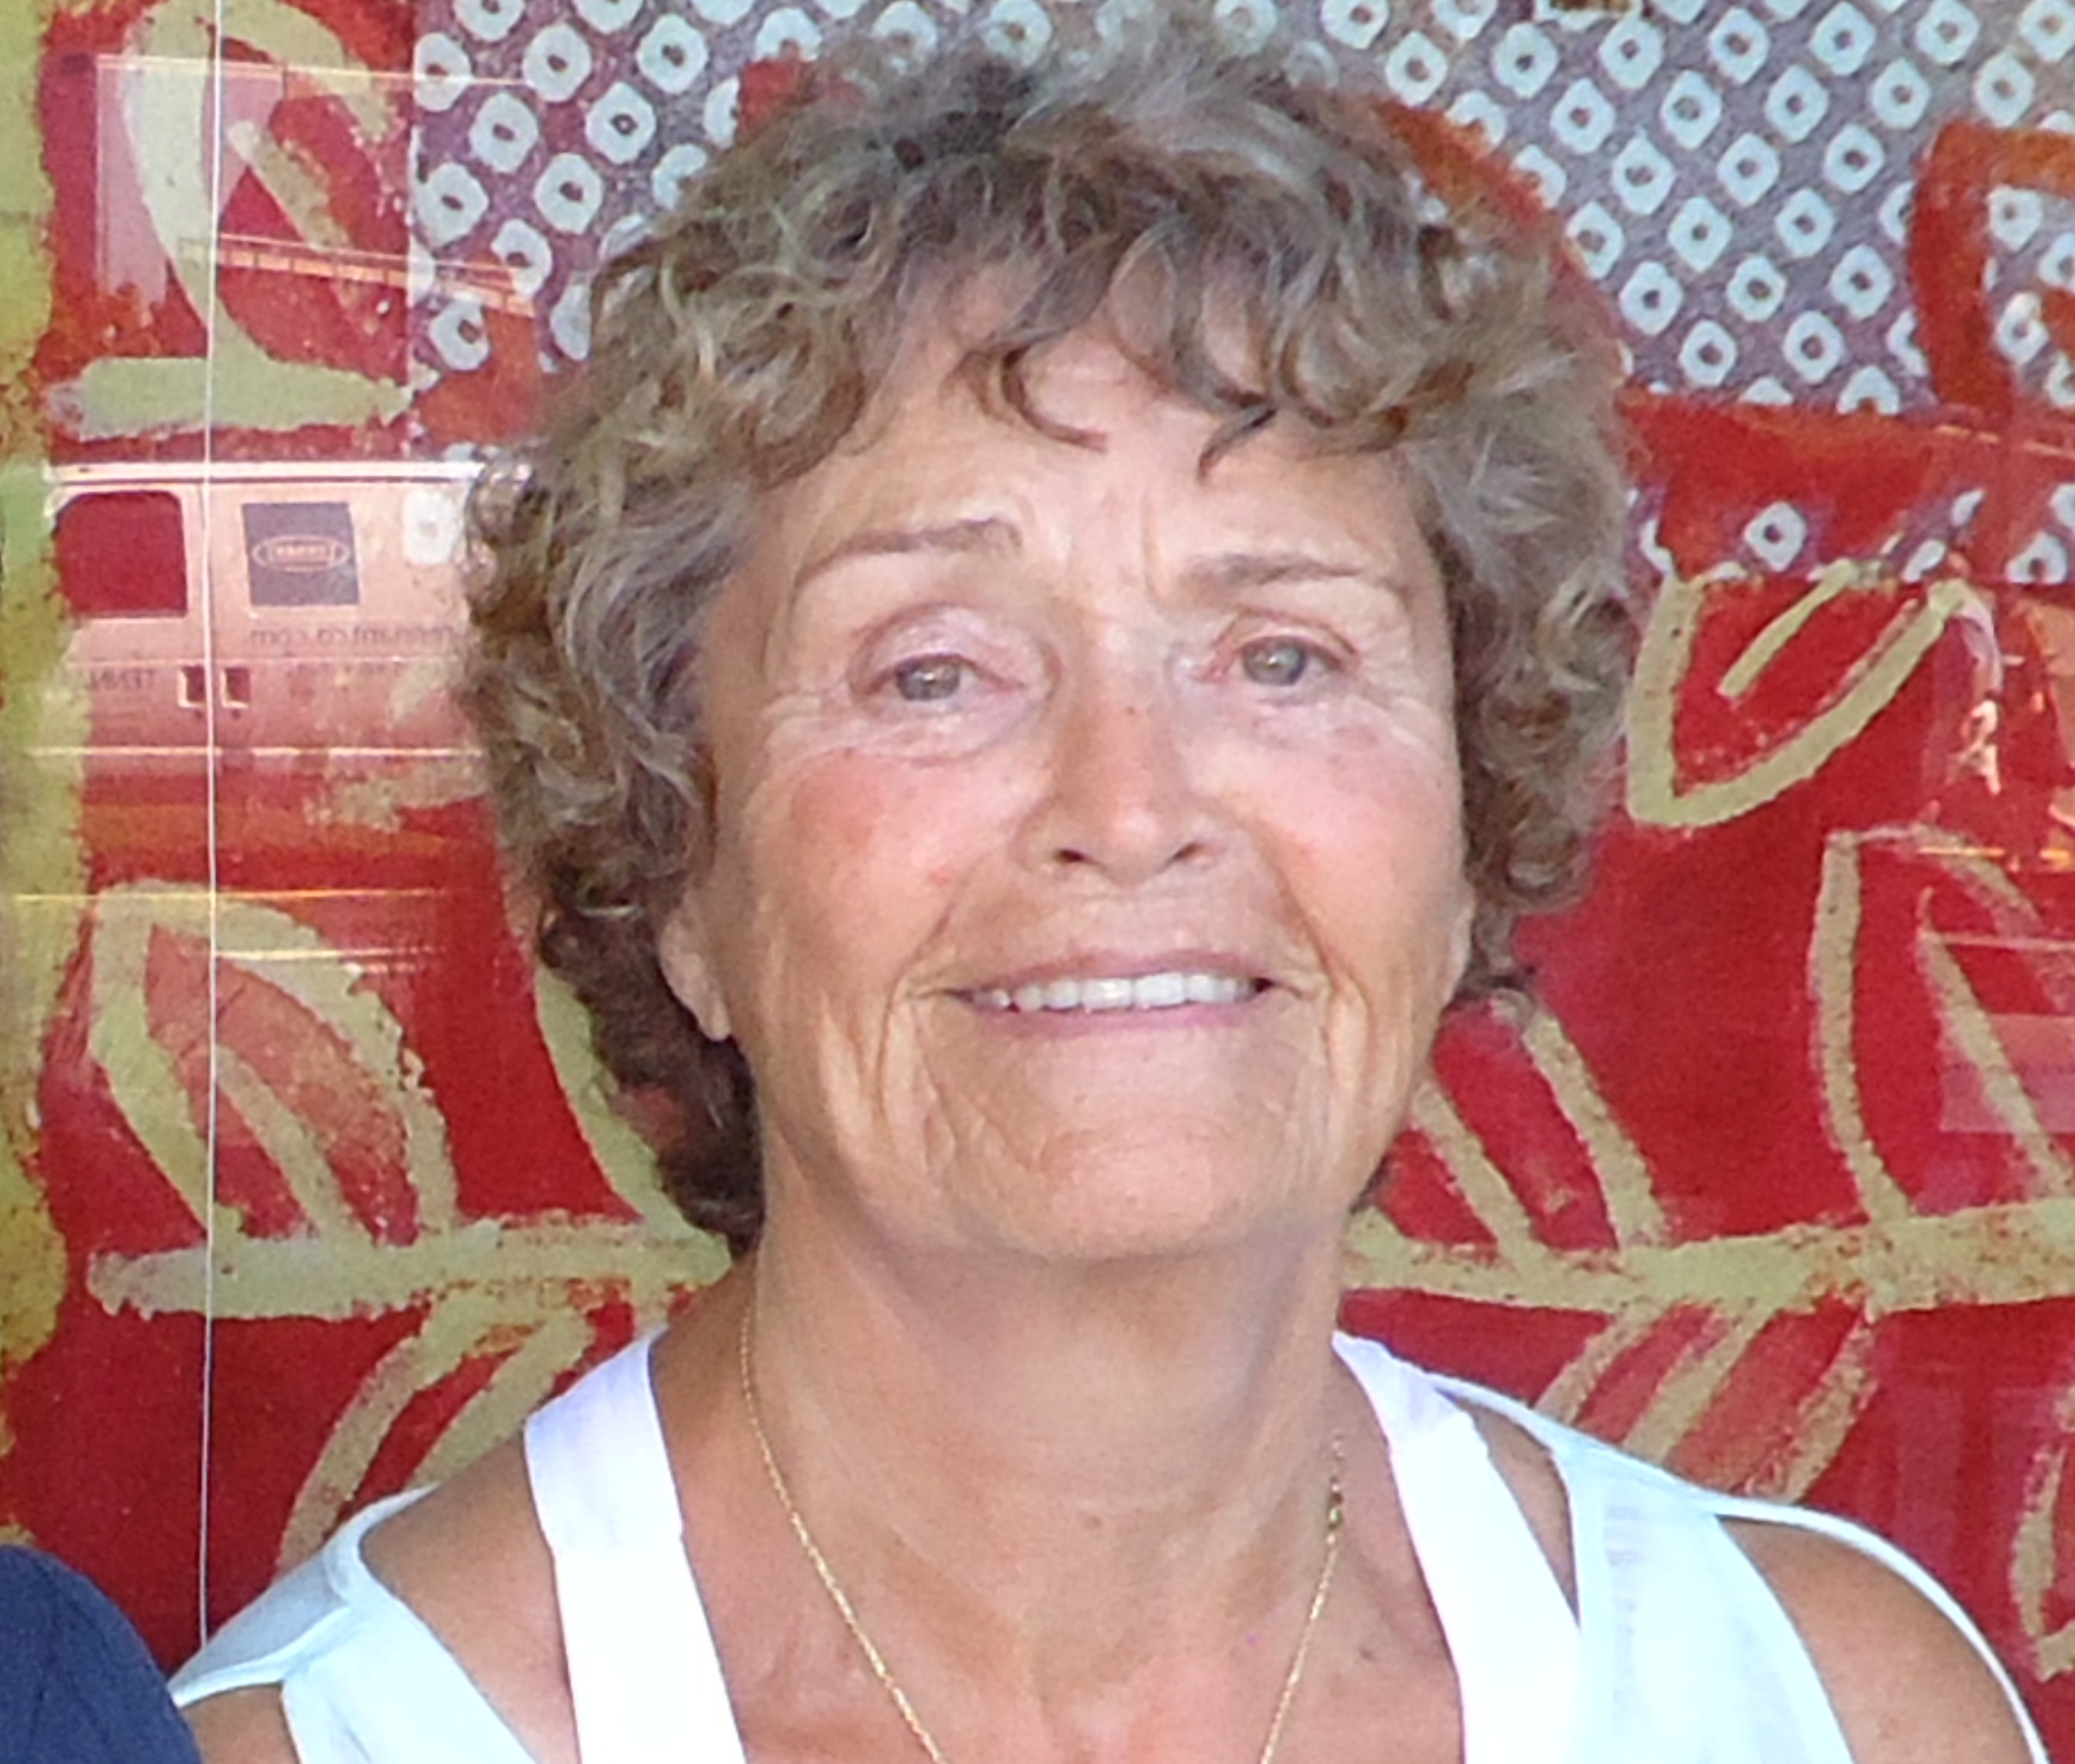

Area of Expertise:
Women’s Ministry Leader

Mallory, Charlotte

Email: SAVE@fountainbaptist.org

Website:
Contact Address: Fountain Baptist Church 116 Glenside Avenue
Summit, NJ 07901

Home Phone:
Work Phone: (908)273-1199 Cell Phone:

FAX:

Brief Description of Ministry:
SAVE is an empowerment group, of churches, partnering to help women overcome the effects of violence and abuse. Transforming pain into power enhances the quality of life across every age group.

NABWU Member Body/Convention:
WA Lott Carey Baptist, Foreign Mission Convention

Area of Expertise:
Disadvantaged women. Founder and co-leader (with Sharena Turner and Rev. Della Bost) of God’s Lending Hands

McNeely-Boyce, Cynthia

Email: cynbag@sympatico.ca

Website:
Contact Address:
1182 Parkview Ave Windsor, ON N8S 2X9
Home Phone: (519) 251-1635
Work Phone: (519) 257-6231

Cell Phone: FAX:

Brief Description of Ministry:
Provides workshops, discussions, peer mentoring, potluck meals, and biblical guidance to low-income single mothers, plus activities for their children. (2011 NABWU Day of Prayer Project)

NABWU Member Body/Convention:
Canadian Baptist Women of Ontario and Quebec

Area of Expertise:
Transitional support for incarcerated and homeless women
Miller, Cheryl – Executive Director Email:
Website: http://perpetualhelphome.org

Contact Address:
P.O. Box 4305 Victoria, TX 77903 Home Phone:
Work Phone: (361) 575-5335

Cell Phone:

FAX:

Brief Description of Ministry:
Perpetual Help Home, Inc. is a Christian based restorative justice organization assisting women in breaking the cycle of incarceration and homelessness through making life changes, regardless of race, color, or creed. We help women become productive members of society with transitional support, new life-skills training and permanent supportive housing.

NABWU Member Body/Convention:
Woman’s Missionary Union

Area of Expertise:
Serving low income mothers and families in a small city

Owen, Carol

Email: todd@owen.on.ca
Website: friendshiphouse.brant.com

Contact Address:
3 Highway 53, RR1 Burford, ON N03 1A0
Home Phone: (519)449-5182
Work Phone: (519)753-8511 Cell Phone:

FAX:

Brief Description of Ministry:
Program Director of Friendship House which meets its neighbor’s physical, emotional and spiritual needs through a breakfast club, after school programs, ladies Bible Study, food bank, community closet and luncheon and other programs.

NABWU Member Body/Convention:
Canadian Baptist Women of Ontario and Quebec

Area of Expertise:
Intentional Innovative Community Evangelism (IICE)

Yandell, Marjorie

Email: vmy@att.net

Website:
Contact Address:
500 Baker Road
Fredonia, KY 42411
Home Phone: (270)545-3429
Work Phone: (270)545-3429 Cell Phone:

FAX:
Brief Description of Ministry:
IICE is a friendly, non-threatening evangelistic outreach that offers free carnival games for block parties hosted by churches. They hope to expand these “Freedom Festivals” to a women’s prison, homeless women, seniors’ homes, and low- income families in public housing. (2012 NABWU Day of Prayer Project)

NABWU Member Body/Convention:
Woman’s Missionary Union

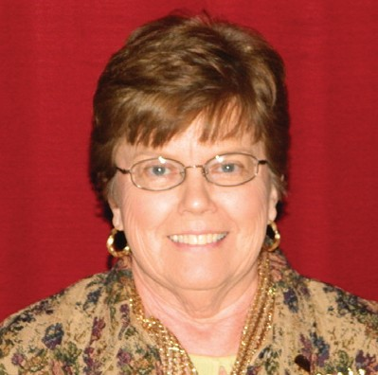

55

NETWORKING
GR OUPS

PRISO N MINISTRIES
/ EX-OFFENDERS

Area of Expertise:
Training and support for pastors and church leaders on the issues of prisoner reentry and aftercare. Working with prison chaplains and lay leaders in networking prison ministries to support each other.

Barrueto, Rev. Fela

Email: Fela.Barrueto@abhms.org

Website:
Contact Address:
P.O. Box 851
Valley Forge, PA 19482-0851

Home Phone:
Work Phone: (800) 222-3872

Cell Phone: FAX:

Brief Description of Ministry:
American Baptist Home Mission Societies ministers as the caring heart, serving hands, going feet and prophetic voice of Jesus Christ- establishing ministries of discipleship, community and justice along with equipping and networking followers of Jesus to transform persons, congregations, neighborhoods and cultures throughout the United States and Puerto Rico.

NABWU Member Body/Convention:
American Baptist Women’s Ministries

Area of Expertise:
Sister Connection

Crawford, Rev. Betty M

Email: revbettyc@aol.com

Website:
Contact Address:
1008 Fenton Place
Upper Marlboro, MD 20774

Home Phone:
Work Phone: (301) 333-4367

Cell Phone: FAX:

Brief Description of Ministry:
Sister Connection is an outreach project whose mission is to establish a Christian connection with women living in Group Home Facilities located in our communities with the spiritual nurture and temporal assistance. Sister Connection seeks to establish and/or re-establish a four-fold connection, namely, 1) Connect facility Sisters (residents) to Christ, 2) Connect facility Sisters to His Word and His Church,
3) Reconnect facility Sisters to their Families, 4) Re-connect facility Sisters to the Community

NABWU Member Body/Convention:
Progressive National Baptist Convention Women’s Department

Area of Expertise:
Outreach to Women in Transition, Women In Prison, Reaching Secular Women

Davis, Paula S.

Email: paula.davis@gmail.com

Website:
Contact Address:
162 S. Vista
Auburn Hills, MI 48326
Home Phone: (248) 253-9252
Work Phone: (248) 753-1295

Cell Phone:
FAX: (248) 753-0324

Brief Description of Ministry:
Since November 18, 1995, the Fashion Share Outreach Project has been held at the Trinity Missionary Baptist Church of Pontiac, Michigan. The Fashion Share Outreach is a mission project where women and their children from selected shelters in the area are invited to “share” and are treated as “Queens for the Day”. A beautiful lunch is prepared, encouraging words are spoken, and the guests are given the opportunity to “shop” for clothing is displayed as in a clothing department store. Child care is provided for their children and includes fun activities and a lunch more to their liking (pizza, hot dogs and hamburgers), clothing and school supplies are also made available. The main message of this outreach is to give dignity and respect to women who are attempting to make a transition to get back on their feet, attend school or return to the workforce in their efforts to make a respectable living for them and their children. The mandate for the project comes from the Holy Word found in Matthew 25:35-40.

NABWU Member Body/Convention:
Woman’s Auxiliary to the National Baptist Convention, USA, Inc.

Area of Expertise:
Federal Prison for male inmates, Springhill, NS

Janzen, Rev. Wilma

Email: wilma.janzen@gmail.com
Website:  Contact Address:  1067 Upper Church Street. Kentville, NS, Canada B4N 3V7 Home Phone:  Work Phone: (902) 678-3641  Cell Phone: FAX:  Brief Description of Ministry:  Prison Chaplain, conducts worship counseling | services, | spiritual care,
NABWU Member Body/Convention:
Atlantic Baptist Women

Area of Expertise:
Vocational training and addictions counseling for women in prison

Jones, Evelyn J.

Email: evelyn.jones@live.com

Website:
1118 Railton Road
Memphis, TN 38111

Home Phone:
Work Phone: (901) 581-0553

Cell Phone: FAX:

Brief Description of Ministry:
Presenter at Jail East, Memphis, TN. Volunteer at the Shelby County Jail East Women’s facility in partnership with Historic New Bethel Missionary Baptist Church. Teaches the life and job skills inmates need to stay out of prison. (see 2011 Tie Cover story).

NABWU Member Body/Convention:
Woman’s Auxiliary to the National Baptist Convention, USA, Inc.

Area of Expertise:
Former Chaplain and current volunteer at TN Prison for women.

Knott, Linda

Email: dixiemk@gmail.com

Website:
Contact Address:
3911 Dodson Chapel Rd, #18
Hermitage, TN 37076

Home Phone:
Work Phone: (615) 741-1255

Cell Phone: FAX:

Brief Description of Ministry:
Leads a Bible study for a hundred inmates every Sunday at the Tennessee Prison for Women, assisted by facilitators.
(See 2011 Tie Cover Story)

NABWU Member Body/Convention:
Woman’s Missionary Union

Area of Expertise:
Ministry to women coming out of incarceration

Leathers, Linda

Email: linda@thenextdoor.org

Website: www.thenextdoor.org
Contact Address: 128 8th Ave. S. Nashville, TN 37203 Home Phone:
Work Phone: (615) 516-9342

Cell Phone: FAX:

Brief Description of Ministry:
Executive Director of The Next Door Ministry providing transitional housing and recovery support services for women leaving prison, rehabilitation services and domestic violence shelters. (See 2011 Tie Cover Story)

NABWU Member Body/Convention:
Woman’s Missionary Union

Area of Expertise:
Transitional support for incarcerated and homeless women
Miller, Cheryl – Executive Director Email:
Website: http://perpetualhelphome.org

Contact Address:
P.O. Box 4305 Victoria, TX 77903 Home Phone:
Work Phone: (361) 575-5335

Cell Phone

FAX:

Brief Description of Ministry:
Perpetual Help Home, Inc. is a Christian based restorative justice organization assisting women in breaking the cycle of incarceration and homelessness through making life changes, regardless of race, color, or creed. They help women become productive members of society with transitional support, new life-skills training and permanent supportive housing.

NABWU Member Body/Convention:
Woman’s Missionary Union

Area of Expertise:
Ministry to women coming out of incarceration

Mobbs, Lucretia

Email: lucretia.mobbs@thenextdoor.org

Website: www.thenextdoor.org
Contact Address:
PO Box 23336
Nashville, TN 37202

Home Phone:
Work Phone: (615) 251-8805

Cell Phone: FAX:

Brief Description of Ministry:
Project Coordinator of The Next Door Ministry providing transitional housing and recovery support services for women leaving prison, rehabilitation services and domestic violence shelters. (See 2011 Tie Cover Story)

NABWU Member Body/Convention:
Woman’s Missionary Union

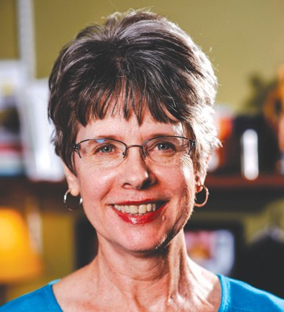

Area of Expertise:
Correctional ministries and chaplains

Swanson, Dr. Karen

Email: karen.swanson@wheaton.edu
Website: www.cmcainternational.com
Contact Address: IPM, 500 College Avenue,
Wheaton, Illinois 60187
Home Phone:
Work Phone: (630) 752-5727

Cell Phone: FAX:

Brief Description of Ministry:
Founding member of Correctional Ministries and Chaplains Association (CMCA). Mission is to connect, encourage, equip and strengthen Christians as they fulfill the Great Commission in Corrections.

NABWU Member Body/Convention:
North American Baptist Conference

Area of Expertise:
Intentional Innovative Community Evangelism (IICE)

Yandell, Marjorie

Email: vmy@att.net

Website:
Contact Address:
500 Baker Road
Fredonia, KY 42411
Home Phone: (270)545-3429
Work Phone: (270)545-3429 Cell Phone:

FAX:

Brief Description of Ministry:
IICE is a friendly, non-threatening evangelistic outreach that offers free carnival games for block parties hosted by churches. They hope to expand these “Freedom Festivals” to a women’s prison, homeless women, seniors’ homes, and low- income families in public housing. (2012 NABWU Day of Prayer Project)

NABWU Member Body/Convention:
Woman’s Missionary Union

67

NETWORKING
GR OUPS

REFUGEES

NEW

IMMIGRANTS

Area of Expertise:
Counseling / refugees

Abele, Erika

Email: erikaoasis@rogers.com
Website: http://www.oasisdufferin.org Contact Address:
36 Connorvale Ave Etobicoke, ON M6H 4C2 Home Phone:
Work Phone: (416) 536-3197

Cell Phone: FAX:

Brief Description of Ministry:
Counseling and settlement services for newcomers and refugees to Toronto. This generally involves providing counseling for women who are experiencing depression, anxiety and culture shock. (2012 NABWU Day of Prayer Project)

NABWU Member Body/Convention:
Canadian Baptist Women of Ontario and Quebec

Area of Expertise:
Settlement Counsellor

Carline, Kelly

Email: k.carline@saintjohny.com

Website:
Contact Address:
474 Hampton Rd
Quispaamsis, NB Canada E2E 3W8
Home Phone: (506) 849-8775
Work Phone: (506) 646-2382

Cell Phone: FAX:

Brief Description of Ministry:
Settlement Counsellor at the YMCA-YWCA of Grater Saint John; also works with her husband Paul, Director of Intercultural Ministries for the Convention of Atlantic Baptist Churches.

NABWU Member Body/Convention:
Atlantic Baptist Women

Area of Expertise:
Helping Hands Refugee Assistance Program

Litz, Alyce

Email: Website:
Contact Address:
115 White Oak Dr Wheaton, IL 60187-4644
Home Phone: (630) 668-2244

Work Phone:
Cell Phone: (603) 921-2233

FAX:

Brief Description of Ministry:
Unpaid Director for Refugee Ministry Information at Village Green Baptist Church in Glen Ellyn, IL, providing service to 25 Somali Bantu refugee families in the Wheaton-Glen Ellyn Area. Program consist of Teaching basic housekeeping skills, English conversation, crafts, cooking lessons and children’s activities.

NABWU Member Body/Convention:
North American Baptist Conference

Area of Expertise:
Director of Matthew House-Windsor

Mantle, Heather

Email: heatherfmantle@hotmail.com Website: http://matthewhousewindsor.org Contact Address:
1095 Janisse Dr. Windsor, ON N8S 2V9
Home Phone: (519) 944-2385

Work Phone: Cell Phone: FAX:

Brief Description of Ministry:
Directs a home that provides short-term housing, Christian friendship, and resettlement assistance to newly-arrived refugees who enter Canada via Detroit

NABWU Member Body/Convention:
Canadian Baptist Women of Ontario and Quebec

Area of Expertise:
Ministry to refugees and victims of human trafficking

Phillips, Cathie

Email: dcphillips2006@yahoo.ca

Website:
Contact Address:
4651C Kingston Road Scarborough, ON M1E 2P8 Home Phone:
Work Phone: (416) 735-4661

Cell Phone: FAX:

Brief Description of Ministry:
Extensive and intensive international experience at the hub of the refugee and human trafficking highways

NABWU Member Body/Convention:
Canadian Baptist Women of Ontario and Quebec

Area of Expertise:
Helping Hands Refugee Assistance Program

Rosio, Jean

Email: Jjrosio@att.net

Website:
Contact Address: 246 McCreey Ave Glen Ellyn, IL 60137
Home Phone: (630) 469-1767

Work Phone:
Cell Phone: (630) 981-7973

FAX:

Brief Description of Ministry:
Volunteer for Refugee Ministry Information at Village Green Baptist Church in Glen Ellyn, IL, providing service to 25 Somali Bantu refugee families in the Wheaton-Glen Ellyn Area. Program consist of Teaching basic housekeeping skills, English conversation, crafts, cooking lessons and children’s activities.

NABWU Member Body/Convention:
North American Baptist Conference

Area of Expertise:
Support Ministry for Live-In Caregivers and Nannies employed by families to care for children or seniors.

Stafford, Gloria

Email: gloriastafford@ymail.com Website: www.thornhillbaptist.ca Contact Address:
8018 Yonge St. Thornhill, ON L4J 1W3
Home Phone: (416) 418-4489
Work Phone: (905) 889-0679

Cell Phone: FAX:

Brief Description of Ministry:
The caregivers are part of the Caregiver Program instituted by the Canadian government. Most are from the Philippines, and most are women. This ministry provides a place where they can connect with other caregivers. Meetings often include topics such as burnout and stress, communication, employer/employee relations and finances. Also provides counseling to caregivers who are coping with the challenges of being separated from family members in their homeland and assist caregivers who are searching for jobs and need help preparing resumes.

NABWU Member Body/Convention:
Canadian Baptist Women of Ontario and Quebec

Area of Expertise:
Refugee housing, resettlement, and advocacy

Woolger, Anne

Email: anne@matthewhouse.ca Website: www.matthewhouse.ca Contact Address:
Matthew House 67 Shirley St.
Toronto, ON M6K 1T2

Home Phone:
Work Phone: (416) 364-8287

Cell Phone: FAX:

Brief Description of Ministry:
Matthew House-Toronto comprises several houses in downtown Toronto that welcome and assist newly arrived refugee claimants. Since opening in 1998, we have welcomed and assisted more than 1000 refugees from over 80 different nations.

NABWU Member Body/Convention:
Canadian Baptist Women of Ontario and Quebec

Area of Expertise:
Ministry to internationals

Wyatt, Kimberly

Email: wyatt@thefellowship.info Website: www.cbfinternationals.org Contact Address:
12103 Oakwood View Drive
Apt. 210
Raleigh, NC 27614

Home Phone:
Work Phone: (613) 521-4918

Cell Phone: FAX:

Brief Description of Ministry:
Seek to catalyze and mobilize the body of Christ and others who seek to be a blessing to connect with the newcomers in their midst.

NABWU Member Body/Convention:
Cooperative Baptist Fellowship

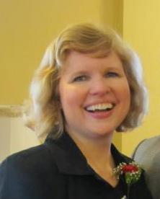

77

NETWORKING
GR OUPS

TRAUMA

Area of Expertise:
Pastoral Care Counseling, specializing in traumatic injury

Clifton, Rev. Dr. Angelita

Email: POAC@aol.com; SAVE@fountainbaptist.org

Website:
Contact Address: Fountain Baptist Church 116 Glenside Avenue
Summit, NJ 07091

Home Phone:
Work Phone: (908) 273-1199

Cell Phone: FAX:

Brief Description of Ministry:
1.) Anti-Trafficking Initiative mobilizing to work and pray for women victimized by gender-based violence. 2.) SAVE is an empowerment group helping women overcome violence, abuse and traumatic events. 3.) CAN is a commission of compassionate caregivers from multiple ministerial initiatives partnering to do God’s work domestically and abroad.

NABWU Member Body/Convention:
WA Lott Carey Baptist, Foreign Mission Convention

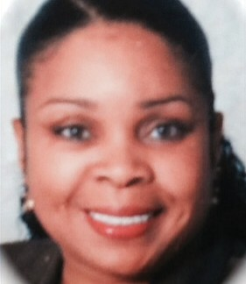

Area of Expertise:
Children/at risk youth, Refugees, Homelessness, Muslim women, Abuse, Joblessness, Sexual addiction, Women in prison, Reaching secular women, Human trafficking, Drug abuse, Environment, Ex- offenders

Doak, Rev. Joanna

Email: joannadoak@yahoo.com Website: http://chameleonjo.com Contact Address:
579 Squires Street
Fredericton, NB Canada E3B 3V3

Home Phone:
Work Phone: (506)455-4157 Cell Phone:

FAX:

Brief Description of Ministry:
Writes and performs dramas in both secular & Christian venues on any or all of the listed subjects.

NABWU Member Body/Convention:
Atlantic Baptist Women

Area of Expertise - Mental Health; Acute Care; Bereavement Support

Rev. Pamela Estey

Hospital Chaplain
Nova Scotia Health Authority Central Zone

Contact Address:
271 Wright Lake Run, Upper Tantallon, NS B3Z 0M3
Email: pamela.estey@nshealth.ca or pamela.estey@bellaliant.net
Work Phone: (902)465-8472
Cell Phone: (902)826-2589
Home Phone: (902)698-0097

I work full-time as a hospital chaplain providing spiritual care to people of varied faith backgrounds including a significant amount of crisis and end-of-life care to patients and families, as well as support to other staff members. More specifically, a portion of my work is sponsored by the Halifax United Baptist Association and my mandate is to work with the full-time Baptist chaplain, Rev. Adele Crowell, to visit and provide spiritual and religious care for those in the QEII and IWK hospitals who self-identify as Baptist. That work is financially and prayerfully supported by individuals, churches, and our larger CABC family.

NABWU Member Body/Convention:
Atlantic Baptist Women (ABW/UBWMU)

Area of Expertise:
SAVE Support Facilitator / CAN-Christian Action Network / CAN- Kenya Partnership

Goodson, Rev. Jeanette

Email: SAVE@fountainbaptist.org

Website:
Contact Address: Fountain Baptist Church 116 Glenside Avenue
Summit, NJ 07901

Home Phone:
Work Phone: (908) 273-1199

Cell Phone: FAX:

Brief Description of Ministry:
SAVE is an empowerment group, of churches, partnering to help women overcome the effects of violence and abuse. Transforming pain into power enhances the quality of life across every age group. CAN is a commission of compassionate caregivers from multiple ministerial initiatives partnering to do God’s work. This collaborative care model addresses critical-prevention and crisis-intervention issues holistically in the community, both domestically and abroad.

NABWU Member Body/Convention:
WA Lott Carey Baptist, Foreign Mission Convention

Area of Expertise:
Women and men dealing with depression, trauma and pain

Holwyn, Faith

Email: faith.holwyn@gmail.com Website: http://www.groupsofhope.ca Contact Address:
280 Hollywood Ave Toronto, ON M2N 3K9 Home Phone:
Work Phone: (416) 850-7529

Cell Phone: FAX:

Brief Description of Ministry:
Founder of Groups of Hope. This eight-week program, developed while Faith was working as a psychiatric nurse in Canada’s indigenous communities, encourages participants, in groups of 10 to 12, to begin to trust each other and to rediscover the reality of God walking with us through difficult times. A 2010 Day of Prayer offering Project.

NABWU Member Body/Convention:
Canadian Baptist Women of Ontario and Quebec

Area of Expertise:
Workshop and Seminar Facilitator

James, Dr. Kym Yancey
Email: kyanceyjam@msn.com
Website: www.kimyanceyjames.com

Contact Address:
c/o Paradise Baptist Church 348 – 352 15th Avenue
Newark, NJ 07103

Home Phone:
Work Phone: (973)624-6614 Cell Phone:

FAX:

Brief Description of Ministry:
Founder and President of Women of Divine Destiny, Inc. a nonprofit organization which endeavors to empower Christian women in leadership to “give the best of their service” to both church and community. Shares a model ministry that engages women who courageously describe their victimization, empowering them to break the silence of abuse while providing a safe, nurturing environment in which the victims may begin the lengthy process of healing.

NABWU Member Body/Convention:
Woman’s Auxiliary to the National Baptist Convention, USA, Inc.

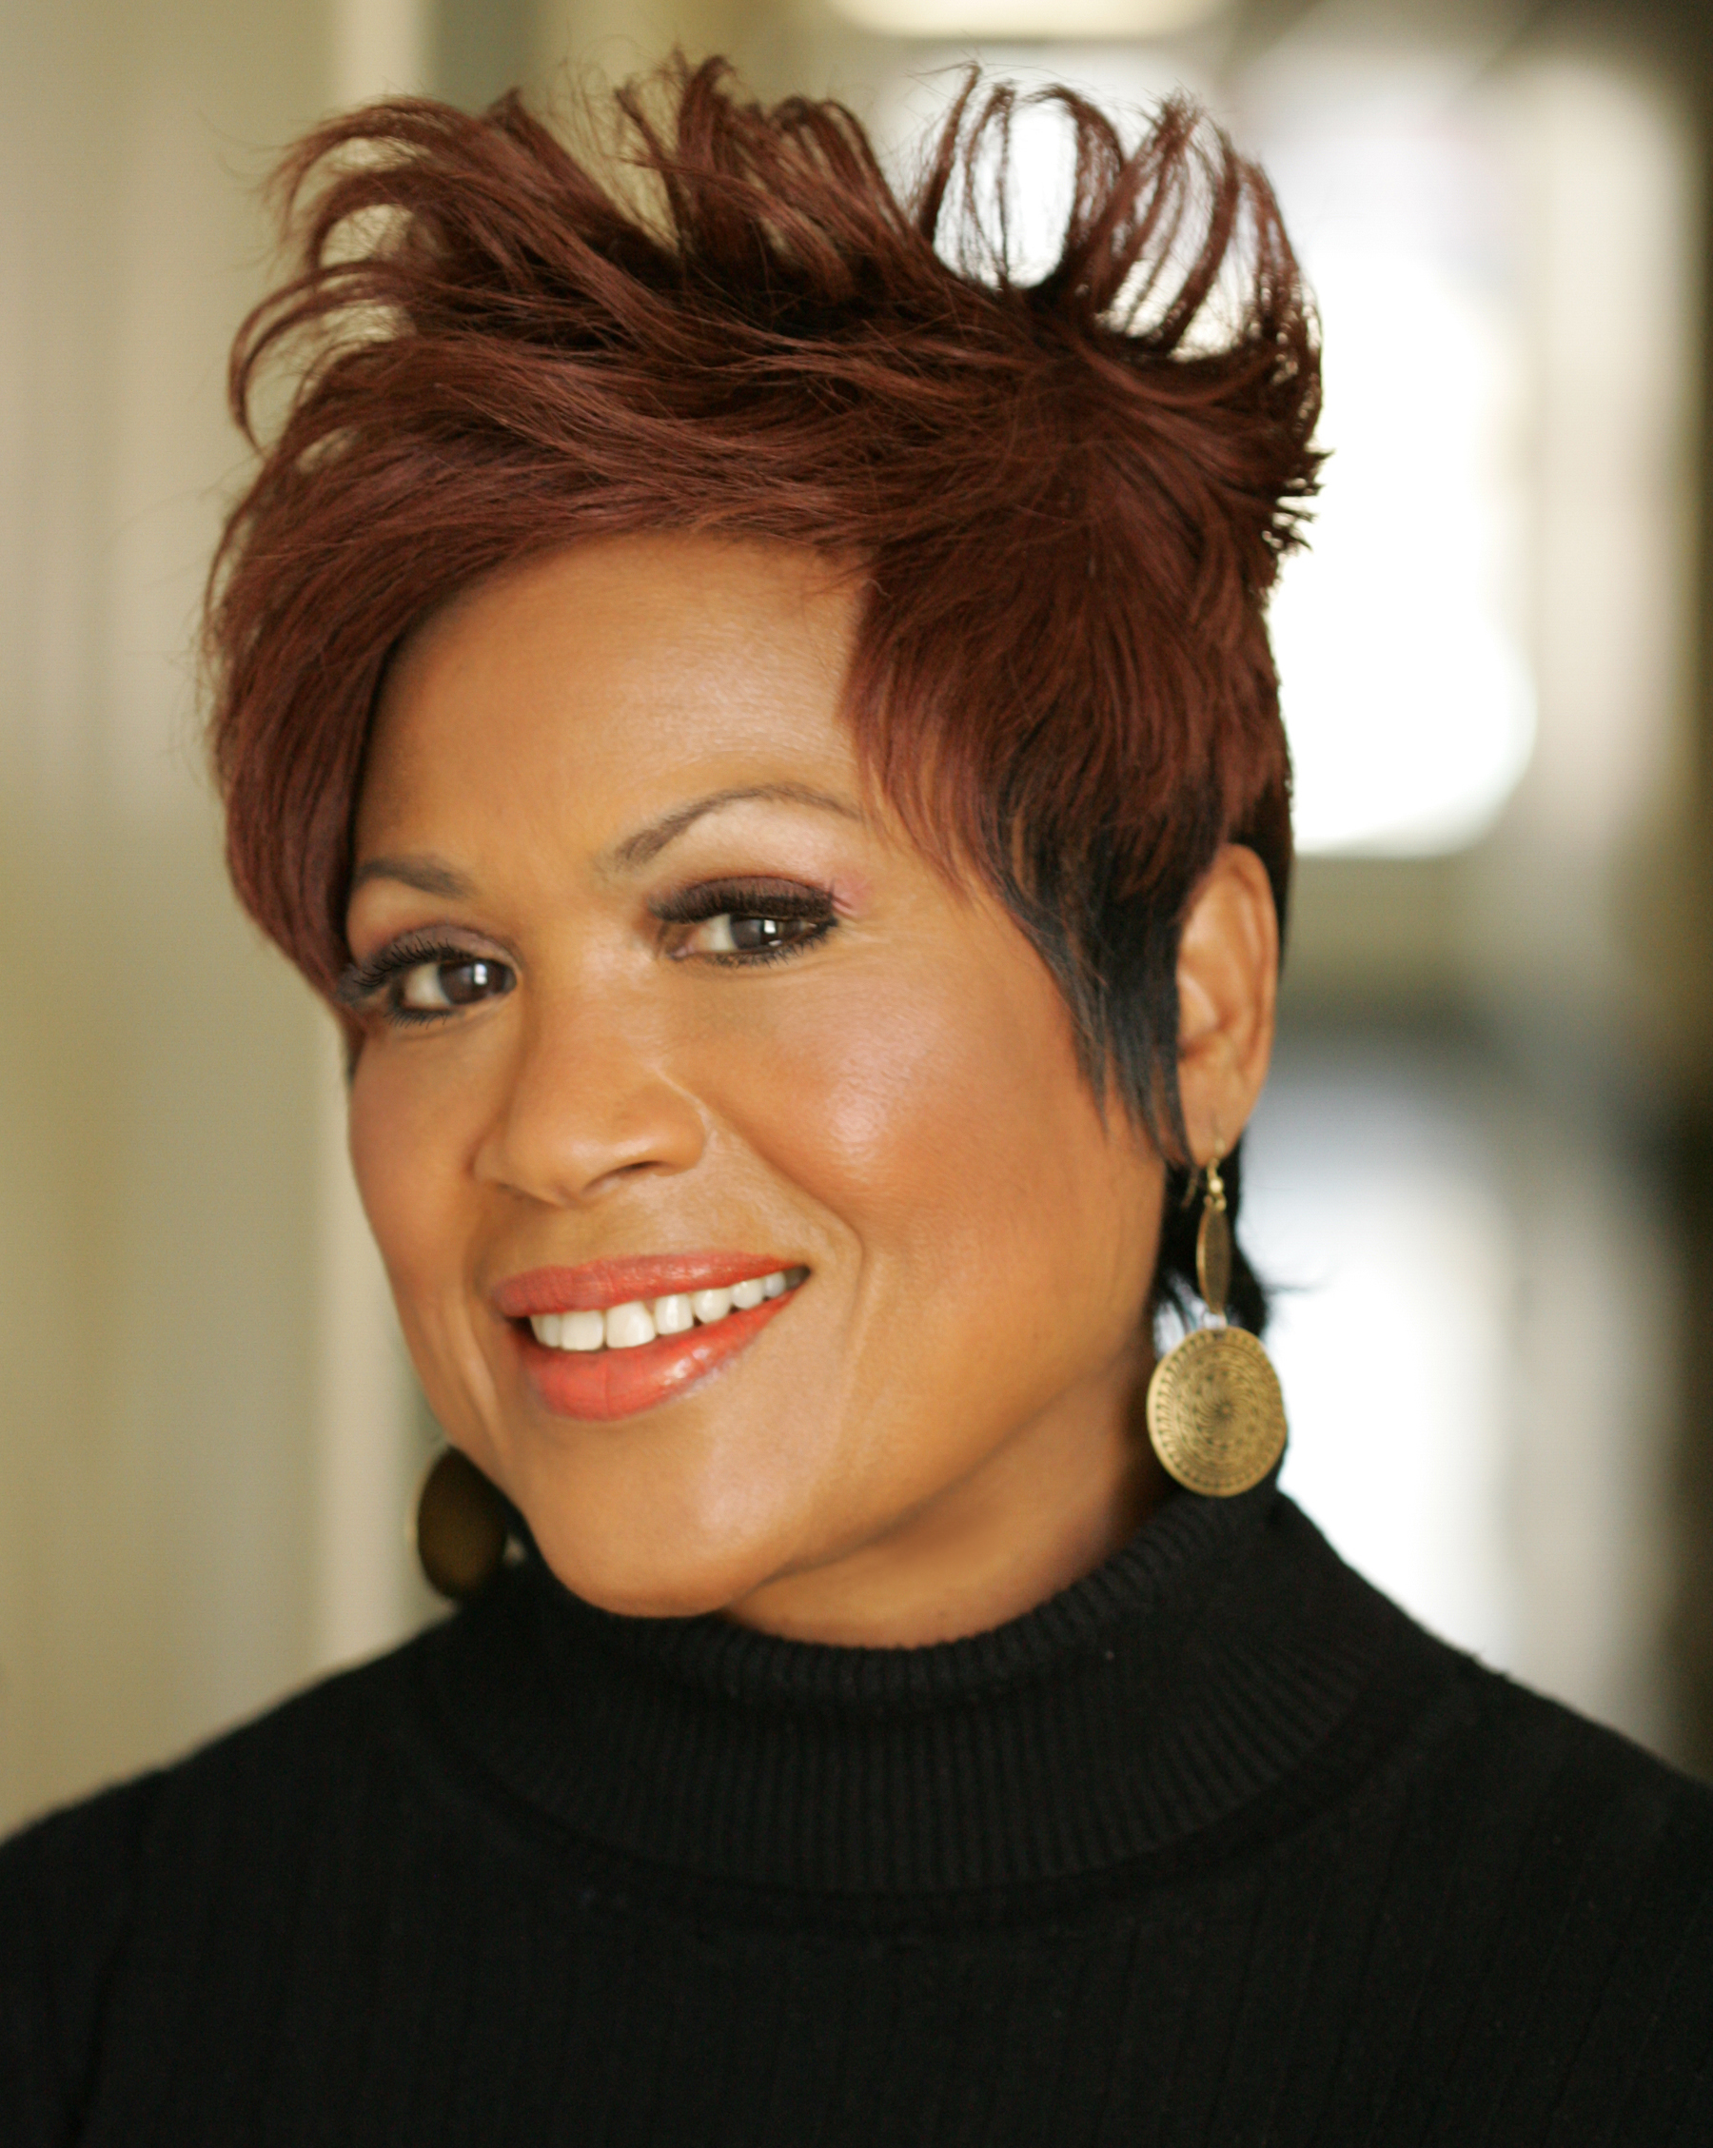

Area of Expertise:
Ministry to women coming out of incarceration

Leathers, Linda

Email: linda@thenextdoor.org Website: http://www.thenextdoor.org Contact Address:
128 8th Ave. S. Nashville, TN 37203 Home Phone:
Work Phone: (615)516-9342 Cell Phone:

FAX:

Brief Description of Ministry:
Executive Director of The Next Door Ministry providing transitional housing and recovery support services for women leaving prison, rehabilitation services and domestic violence shelters.
(See 2011 Tie Cover Story)

NABWU Member Body/Convention:
Woman’s Missionary Union

Area of Expertise:
Advocate on behalf of women and children in the Maryland, Washington, DC; Virginia; and Northern Carolina areas.

McBorrough, Reverend Brenda

Email: brenda.mcborrough@gmail.com

Website:
Contact Address:
6600 Old Centerville Rd Centerville, VA 20120 Home Phone:

Work Phone:
Cell Phone: (571) 216-4861

FAX:

Brief Description of Ministry:
Anti-Trafficking Initiative mobilizing to work and pray for women victimized by gender based violence.
Realizing Every Dream (R.E.D.) Project - empowering vulnerable women in Liberia, Kenya, South Africa, and the U.S.

NABWU Member Body/Convention:
WA Lott Carey Baptist, Foreign Mission Convention

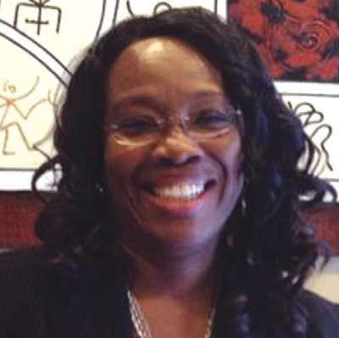

Area of Expertise:
Ministry to women coming out of incarceration

Mobbs, Lucretia

Email: lucretia.mobbs@thenextdoor.org Website: http://www.thenextdoor.org Contact Address:
PO Box 23336
Nashville, TN 37202

Home Phone:
Work Phone: (615) 251-8805

Cell Phone: FAX:

Brief Description of Ministry:
Project Coordinator of The Next Door Ministry providing transitional housing and recovery support services for women leaving prison, rehabilitation services and domestic violence shelters. (See 2011 Tie Cover Story)

NABWU Member Body/Convention:
Woman’s Missionary Union

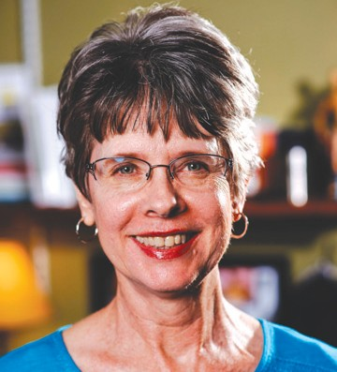

Area of Expertise:
Emmaus CARES (Childhood Abuse Recovery and Education Services)
Murphy, Ruthe - Director Email: ruthemurphy09@gmail.com
Website: www.emmauscares.com

Contact Address:
981 Notre Dame Drive London, ON N6J 3C3
Home Phone: (519) 474-7711
Work Phone: (855) 896-7710

Cell Phone: FAX:

Brief Description of Ministry:
Helps adult survivors of childhood abuse and neglect through Road to Hope groups, training for group leaders, counseling, the “Why is Life So Hard?” booklet, and education of church and social service leaders.

NABWU Member Body/Convention:
Canadian Baptist Women of Ontario and Quebec

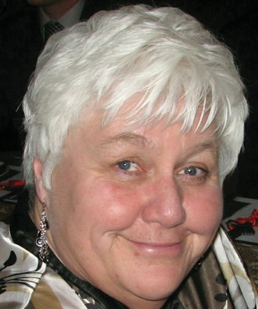

Area of Expertise:
Emmaus CARES (Childhood Abuse Recovery and Education Services)
Root Parr, Rev. Kathy – Assistant Director Email: rootparr@sympatico.ca
Website: www.emmauscares.com

Contact Address:
315 Auburn Avenue London, ON N6J 3K8
Home Phone: (519) 474-4109
Work Phone: (866) 896-7710

Cell Phone: FAX:

Brief Description of Ministry:
Helps adult survivors of childhood abuse and neglect through Road to Hope groups, training for group leaders, counseling, the “Why is Life So Hard?” booklet, and education of church and social service leaders

NABWU Member Body/Convention:
Canadian Baptist Women of Ontario and Quebec

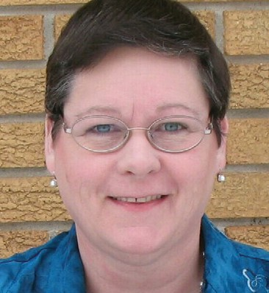

Area of Expertise:
Diversity of Awareness Education: Domestic Violence, Child Abuse, Alcohol and Drug Education

Williams, Debra E.

Email: goldadew@aol.com

Website:
Contact Address:
2114 Cardinal Drive East Chicago, IN 46312 Home Phone:
Work Phone: (219) 398-6223

Cell Phone: FAX:
Brief Description of Ministry:
Diversity of Awareness and Education, Self-Help and Advocacy (Human Services), Family Resource Domestic Violence

NABWU Member Body/Convention:
Woman’s Auxiliary to the National Baptist Convention, USA, Inc.

92

NETWORKING
GR OUPS

WIDO WS

Area of Expertise:
Ministry to Widows

Pearson, Elaine

Email: ekellerp@bellsouth.net Website: http://phoebeministries.com Contact Address:
517 Christy Drive
Lebanon, TN 37087

Home Phone:
Work Phone: (615) 443-7375

Cell Phone: FAX:

Brief Description of Ministry:
Ministry to Widows

NABWU Member Body/Convention:
Woman’s Missionary Union

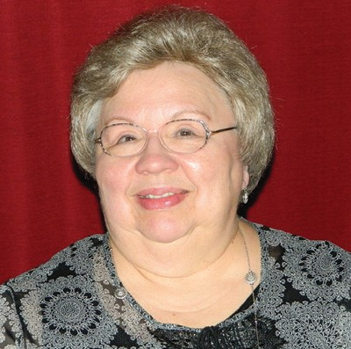

Area of Expertise:
Ministry to Widows

Pharris, Carol

Email: Carolpharris@mac.com Website: http://phoebeministries.com Contact Address:
313 Bethlehem Road
Lebanon, TN 37087

Home Phone:
Work Phone: (615) 443-3742

Cell Phone: FAX:

Brief Description of Ministry:
Ministry to Widows

NABWU Member Body/Convention:
Woman’s Missionary Union

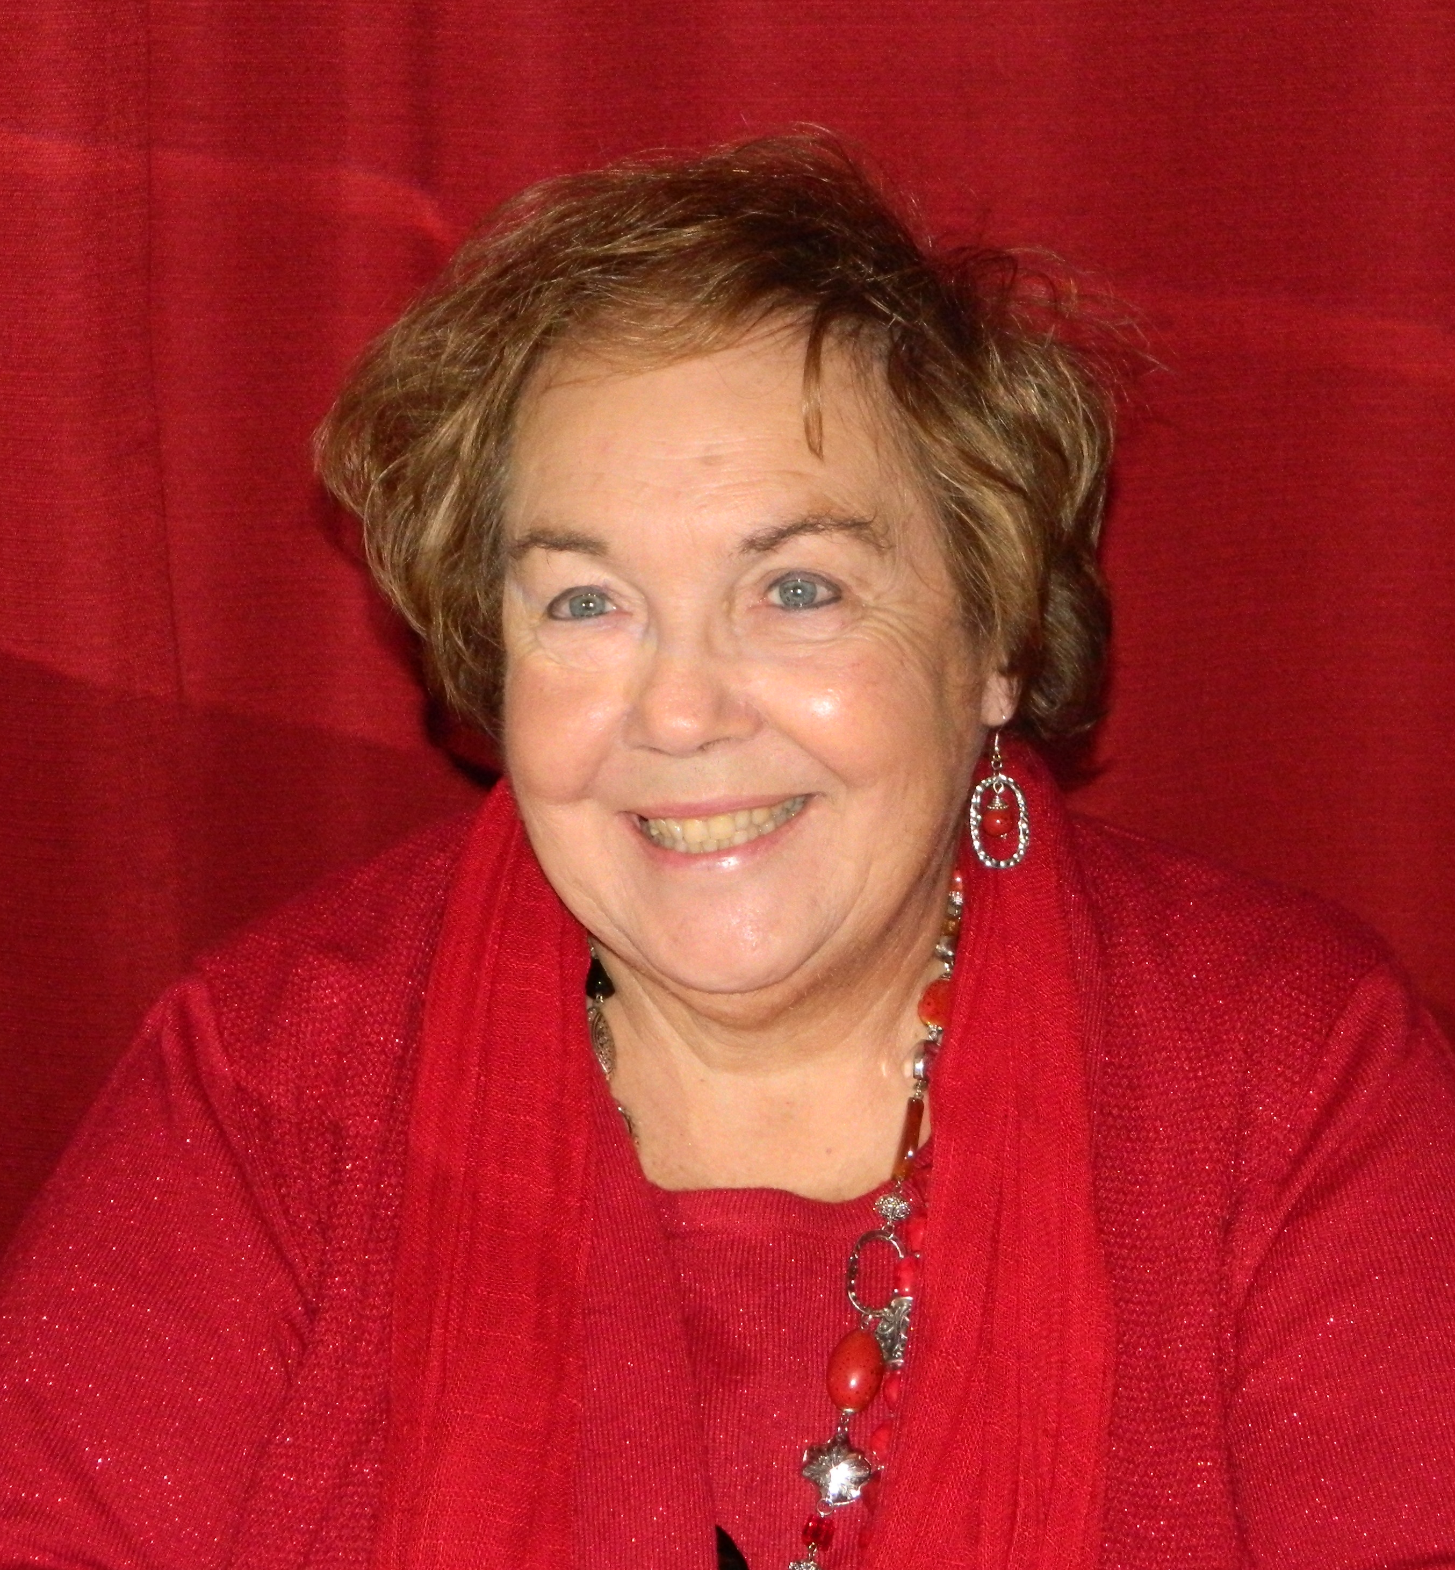

944

NETWORKING
GR OUPS

YOUTH
AT RISK

Area of Expertise:
Disadvantaged children and youth (children of incarcerated parents)

Dozier, Brenda

Email: bdozier@suddenlink.net

Website:
Contact Address:
6232 Grand Oak Dr. Alexandria, LA 71301-2336
Home Phone: (318) 448-3186
Work Phone: (318) 787-3184

Cell Phone: FAX:

Brief Description of Ministry:
DOP Project is Dress for Success, which purchases school supplies and mandatory School uniforms for students aged 15-18. Also leads Mountain Moving Ministries, Alexandria

NABWU Member Body/Convention:
Woman’s Missionary Union

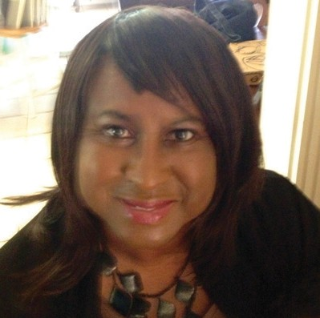

Area of Expertise:
Coordinator of Dream Big 2011, Registrar of Louie’s Place

Germann, Ellyn

Email:
Contact Address: Website:
747 Broad St
Providence, RI 02907
Home Phone: (413) 512-0506
Work Phone: (401) 461-7509

Cell Phone: FAX:

Brief Description of Ministry:
Dream Big is a comprehensive college and career training program for at-risk-female youth aged 15-18. Louie’s Place is an Outreach to women and youth that is part of South Providence Neighborhood Ministries. SPNM is an ecumenical, multi-service neighborhood center.

NABWU Member Body/Convention:
American Baptist Women’s Ministries

Area of Expertise:
Urban Youth at risk

Gillard, Rev. Denise

Email: c.denisegillard@gmail.com Website: http://www.tc3.ca Contact Address:
2 Larkhall Ave Toronto, ON M1J 1V1 Home Phone:
Work Phone: (416) 832-7427
Cell Phone: (416) 939-1702

FAX:

Brief Description of Ministry:
Founder-director of the Toronto Children’s Concert Choir and Performing Arts Company (TC3). Its purpose is to promote, develop, and encourage youth in the musical arts through the medium of inspirational music ranging from spirituals to Hip Hop with a focus on excellence within a combination of holistic development and world class performance.

NABWU Member Body/Convention:
Canadian Baptist Women of Ontario and Quebec

Area of Expertise:
Foster care for children of all ages.

Mills, Dawna-Mae

Email: Domestic_diva@bellnet

Website:
Contact Address:
486 Crestwood Dr Oshawa, ON L1G 2R5
Home Phone:
Work Phone: (905) 404-8993

Cell Phone: FAX:

Brief Description of Ministry:
Has had children in home with varying disabilities from downs syndrome FASD, from spina bifida to being deaf, to varying degrees of trauma/grief. Has also been able to help some of the biological parents with their situations and has seen some wonderful outcomes. Receives monthly training from her agency. Her one area of expertise in fostering has become dealing with children with FASD-Fetal Alcohol Spectrum, Disorder.... She and her husband have adopted 3 children with this disability (and it is a disability) and fostered many with it. Anyone interested in fostering can feel free to contact her about this.

NABWU Member Body/Convention:
Canadian Baptist Women of Ontario and Quebec

Area of Expertise:
Children/at risk youth and Other-Education (Science/Math) ~ Science Education and Teaching / Speaking

Mitchell, Carol T.

Email: cstillwaters@aol.com; cmitchell@mail.unomaha.edu

Website:
Contact Address: 7225 North 70th Ave. Omaha, NE 68152
Home Phone: (402) 571-1441
Work Phone: (402) 554-2428
Cell Phone: (402) 708-2246

FAX:

Brief Description of Ministry:
For the past three years Carol has taken her ministry of teaching science and math to Lesotho and Swaziland. She has taught teachers and students during a science and math workshop. The workshops for both teachers and students have lasted for one week. Additionally, Carol speaks to women both religious and secular about the need for Kingdom work in the here and now. She shares with women around the United States about commitment to the work of Christ. She trains teachers in Christian Education and is writing a book with her twin sister, the Right Reverend Sarah F. Davis on Transformational Teaching.

NABWU Member Body/Convention:
Woman’s Auxiliary to the National Baptist Convention, USA, Inc.

Area of Expertise:
Urban youth and children at risk

Opoku, Kristy

Email:
Website: http://www.frontlines.to

Contact Address:
73 11th St.
Toronto, ON M8V 3G4

Home Phone:
Work Phone: (416) 902-3972

Cell Phone: FAX:

Brief Description of Ministry:
Directs Frontlines, a faith-based community centre that offers cooking classes, tutoring, etc. to at-risk urban youth and children and their families. A 2011 Day of Prayer Offering Project.

NABWU Member Body/Convention:
Canadian Baptist Women of Ontario and Quebec

Area of Expertise:
Urban multi-cultural girls at risk, poverty, arts/dance

Rev. Karen Robinson Joseph

Youth Unlimited (TYFC)
North York Team & Community Pastor

Email: karen@youthunlimitedgta.com

Website: www.youthunlimitedgta.ca

Contact Address:4616 Wayside Court

Mississauga, ON L5V 1G2

Home Phone:
Work Phone: 416-383-1477
Cell Phone: (416) 809-8834

FAX:

Brief Description of Ministry: Works for Youth Unlimited (Toronto Youth For Christ) supervising and managing the North York area staff team of frontline youth and community workers. Karen has extensive frontline experience working with homeless youth, young men and women involved in the sex trade, youth at risk, young mom’s as well as in cross-cultural ministry with youth and running faith based arts programs for youth.

NABWU Member Body/Convention:
Canadian Baptist Women of Ontario and Quebec

Area of Expertise:
Children or At Risk Youth

Sargent, Dr. Evaleen

Email: ELSministries@bellsouth.net

Website:
Contact Address; 3955 Majestic Dr. S.W. Atlanta, GA 30331 Home Phone:
Work Phone: (404) 691-0636
Cell Phone: (404) 316-6862

FAX:

Brief Description of Ministry:
She is the founder of ELS Ministries. Her mission is to empower others to go into all settings continuing Christ’s Ministry of healing and restoration to a broken people. She ministers to children and adults, especially low-income families.

NABWU Member Body/Convention:
Progressive National Baptist Convention Women’s Department

Area of Expertise:
Children or At Risk Youth
Relating to children and youth in teaching God’s Word

Selig, Laura

Executive Director
New Life Mission
Email: laura@newlifemoncton.com
Website: http://webmail.newlifemoncton.com

Contact Address:
New Life Mission
PO Box 2
Moncton, NB E1C 8R9, Canada

Work Phone: 506-859-4277 (O)
Cell Phone: 506-851-1489 (C)

Brief Description of Ministry:
New Life Mission is an after school drop-in program that has 4 locations in the greater Moncton area. There is one location that meets 5 days a week; one that meets 2 days per week and the other 2 meet 1 day per week at the present time. We provide the children with a safe, comfortable environment to come into where they are able to receive homework/literacy assistance, enjoy some fun activities; games and crafts, learn life skills and hear a Bible lesson each day. They are also provided with a healthy snack each day. They also have opportunity to become involved in camping during the summer and other healthy, positive community programs during the school year. We have 141 children passing through our doors this year.

NABWU Member Body/Convention:
UBWMU of Atlantic Canada

Area of Expertise:
At-risk Teen Girls

Styles, Paula

Email: pstyles0807@yahoo.com

Website:
Contact Address: 5535 33rd St. East Bradenton, FL 34203 Home Phone:
Work Phone: (727) 282-3670

Cell Phone: FAX:

Brief Description of Ministry:
Women Insight and Empowerment. Teaching at-risk teen girls to take care of themselves (body, mind and spirit) is the aim of Women In Sight and Empowerment. It provides health screenings, psychosocial assessments, nutritional education, counseling and tools to help ghe girls avoid becoming statistics for teen pregnancy, drug abuse, and domestic violence.

NABWU Member Body/Convention:
General Baptist Women’s Ministries, INC.

